**User**

**Manual**

**User Manual**

**Table of contents**

**1. General information………………………………………………………………………………03**

**1.1 System Overview……………………….……………………………………………………..03**

**1.2 System configuration………………….……………………………………………………...03**

**1.3 System Authors…………………...………………………………………....……………..…04**

**2. Getting Started……………………………………………………………………………………04**

**2.1. Installation of the program…… ……………………………………………………………04**

**2.2. Customizing database location……………………………………………………………...04**

**2.3. Sign up and logging in………………………………………………………………………04**

**2.4. Accessing the bookstore…..……………………………………....……………………..…..07**

**2.5. Logout……………………….………………………………………..…………………..…..07**

**2.6. Admin view …………………………………………………………………………………...08**

1. **General information**

This section explains in general terms the system and the purpose for which it is intended.

* 1. **System Overview**

Rkgel47 online bookstore is an application which allows users to browse the bookstore and purchase books from bookstore as well as allows admin to access and update the database through a GUI (Graphical User Interface). The graphical user interface of the application allows users to browse and purchase their desired books in a convenient way. Moreover it allows admin to insert (new), Update (existing) and delete (existing) books in the database. The application stores the data to a SQLite database called online bookstore.

* 1. **System configuration**

Rkgel47 online bookstore operates on JDK platform with a java supporting IDE. It is compatible with platforms like windows, Linux, mac etc. with the help of JVM. The application is build up on features of java like java swing (panel, label, button, password field, radio button, combo box), java interfaces like Connection, Statement, PreparedStatement, Resultset, etc. to make the program more robust and dynamic. The Java Database Connectivity (JDBC) API is used in the application. The JDBC API provides a call-level API for SQL-based database access.

* 1. **System authors**

The Rkgel47 online bookstore server was created by three member consisting of Rajkumar Shashwata Halder, Mahmudul Hassan Robin and Gerald Nizel Rozario. The system authors tried to provide a fastest, efficient and reliable FTP server for the user which is also very user friendly.

**2. Getting Started**

This section explains how to get Rkgel47 and install it on the device.

**2.1. Installation of the program**

The application is a .java file, which should be installed on the device. This application requires a local drive (E:) to store the program and database.

**2.2. Customizing database location**

If the user unable to provide a local drive (E:) , he/she might have to customize the server location. First open the application with a java supported IDE and navigate to

Connection.java > public Connection connect()> find the line” String url = "jdbc:sqlite: E:/bookstore /OnlineBookstore.db";” . Replace the “E:” driver letter with the desired driver letter in which he/she want to create the server.

**2.3. Sign up and logging in**

After running the application the user will have a window for log in into the bookstore with a login account or signup for a new one.

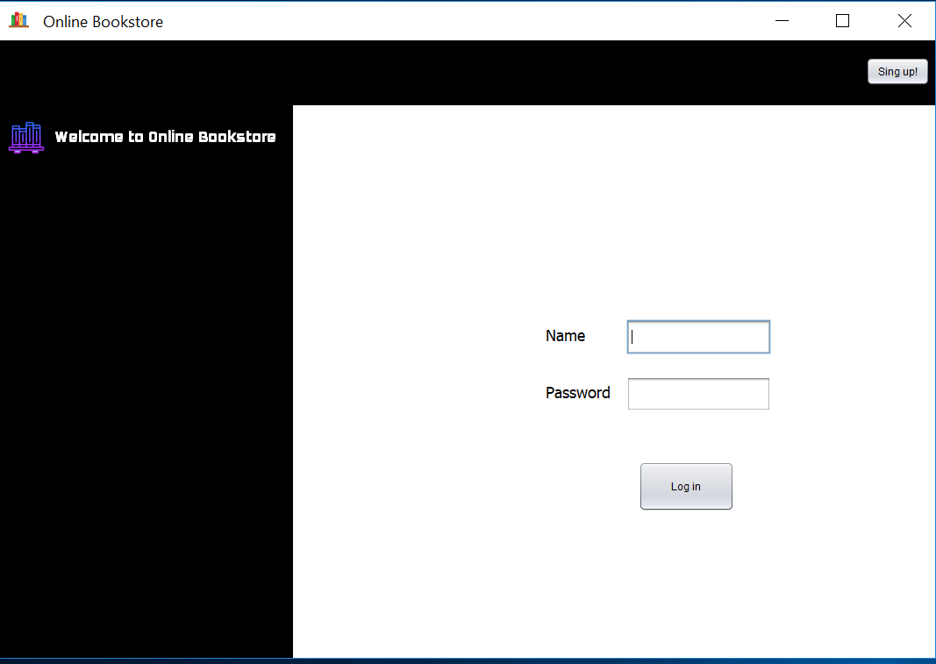

As for the first time the user have to click the “Signup” button to navigate to the Register window to complete the sign up process.

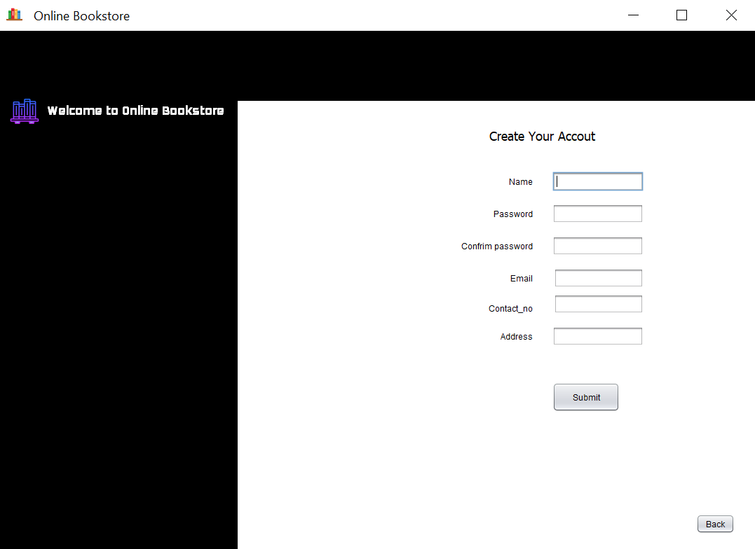

Every field of the register window must be filled to complete a successful registration. After pressing the “submit” button providing proper information the application will allocate a new account for the user to access the bookstore as well as open the browser window.

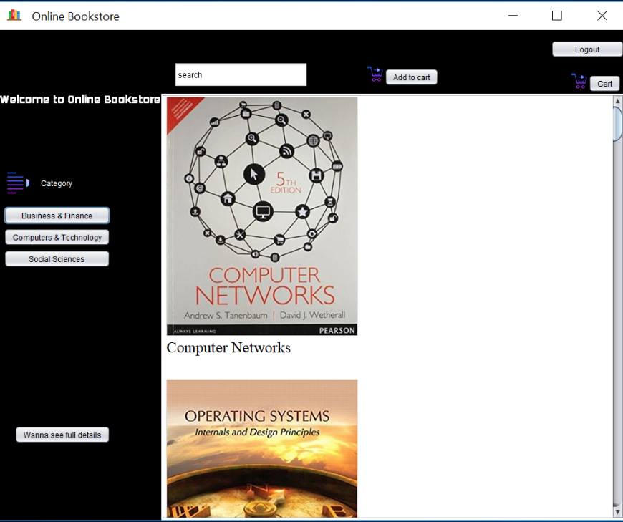

**2.4. Accessing the bookstore**



After a successful login the user will have the bookstore access widow for further operation. User can browse books by category in the bookstore. User can see full details of every book through “Wanna see full details” button. User can also browse books based on category. Search field can also be used to find books from the bookstore based on book name, author name and publisher.

To buy a book user have to select a book name and then select add to cart button to proceed further. Then a pop up window will open to asking the user how many copies user want to buy.

If user input a number larger than the copies in the bookstore then another pop up window will show the existing number of copies that the bookstore has.

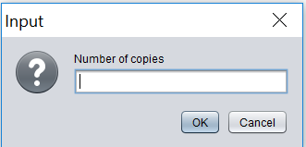 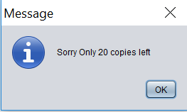

After selection process user will have to click “cart” button to see the list of all book he/she want to buy. User can add more books by clicking “Wanna Buy more books!!” button and browsing the bookstore again. Clear button helps the user to delete a particular entry from the cart. Clear cart button clears the whole cart. When the user is satisfied then he click the confirm purchase to buy books.

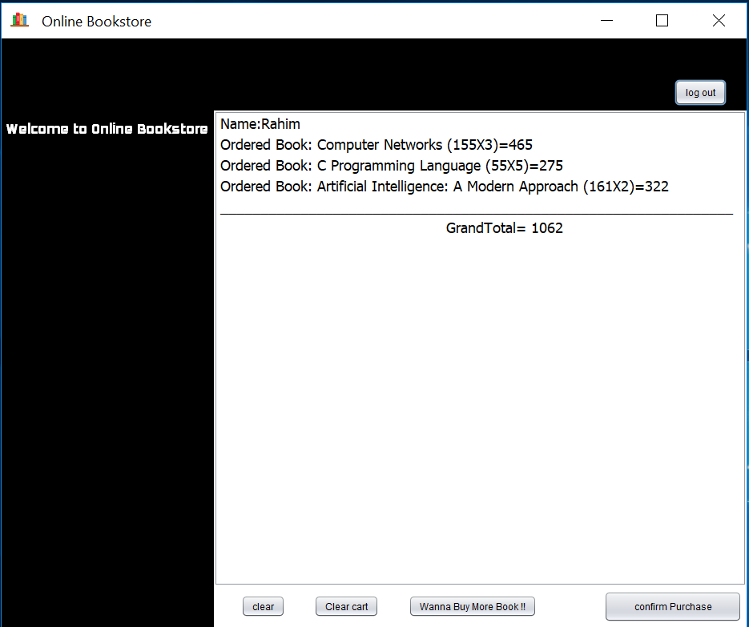

**2.5. Log out**

“Log out” button allows the user to exit from the database after the completion of their desired operation.

**2.5. Admin view**

Admin has different kind of privilege than the user. Admin have to log in the database using Name and password as “admin”.

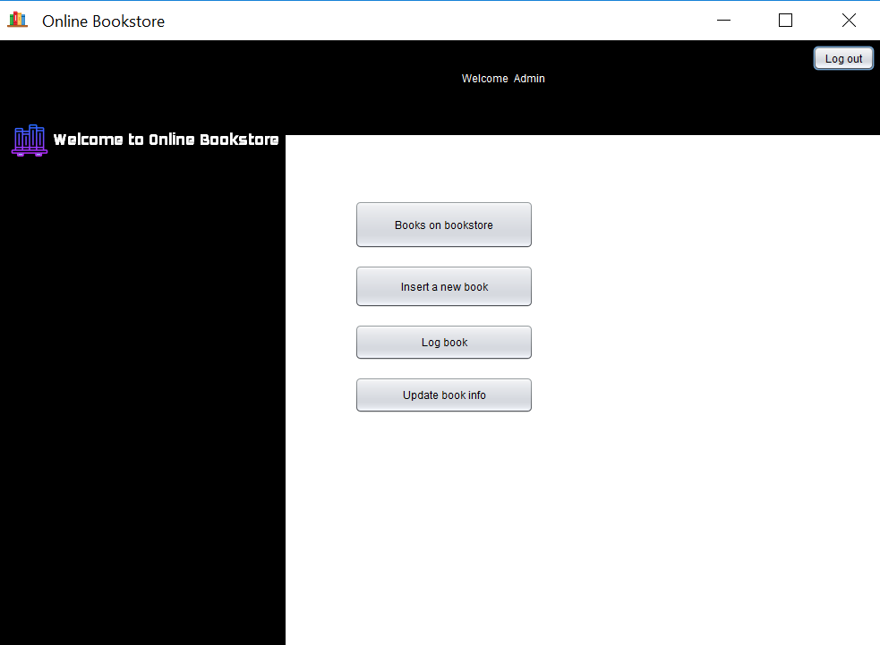

Admin can view the book collection by “clicking books on bookstore” button. Admin can insert a new book by clicking “insert a new book” button.

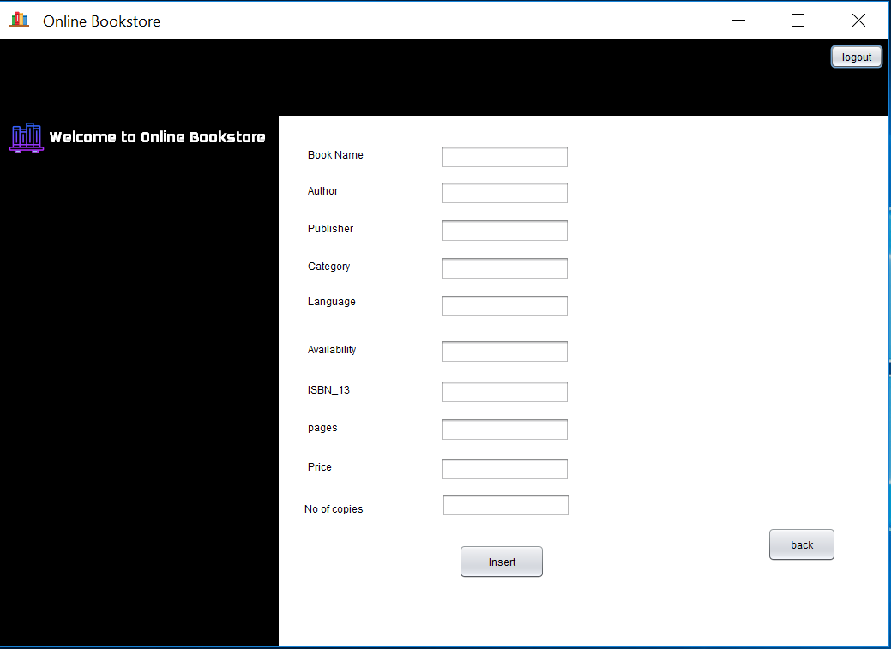

Admin can view the log table by clicking “Log book” button.

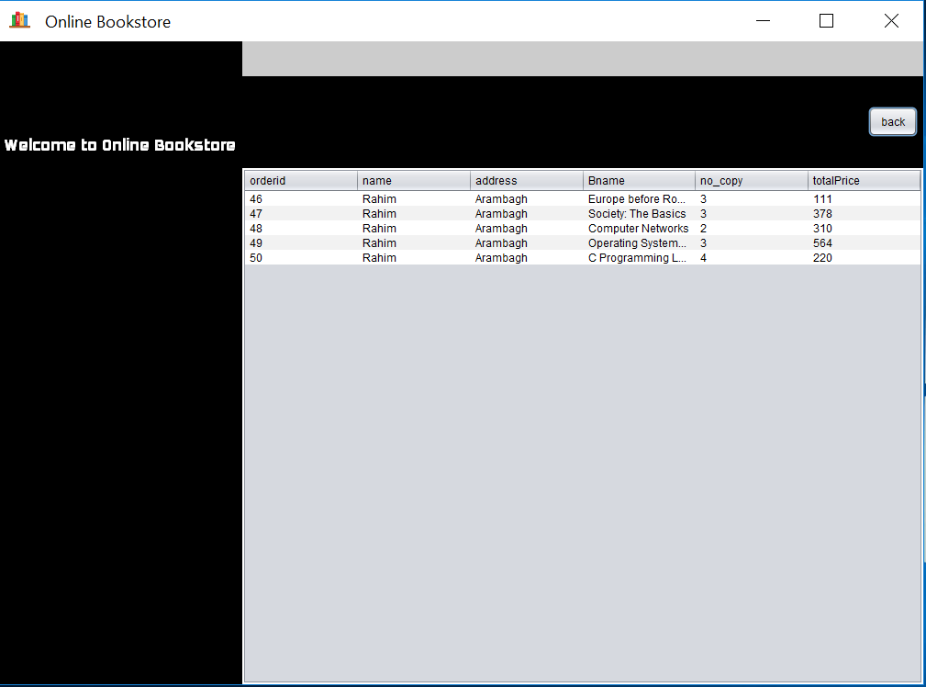

Admin can delete and update a book info by clicking “update book info ” button.

